

CST2120 SOCIAL NETWORKING SITE

SCREENSHOTS SUBMISSION

NAME: Nomsa Tadiwanashe Kachere

STUDENT ID: M00883591

LAB TUTOR: Mrinal Sharma

Contents

Login page 4

Signup page 5

Header 5

Feed page 6

Post page 6

Category page 7

Notification page 8

Profile page 8

Web service 10

Example for POST 10

Second example for POST 11

Example for GET 13

Second example for GET 14

# Login page

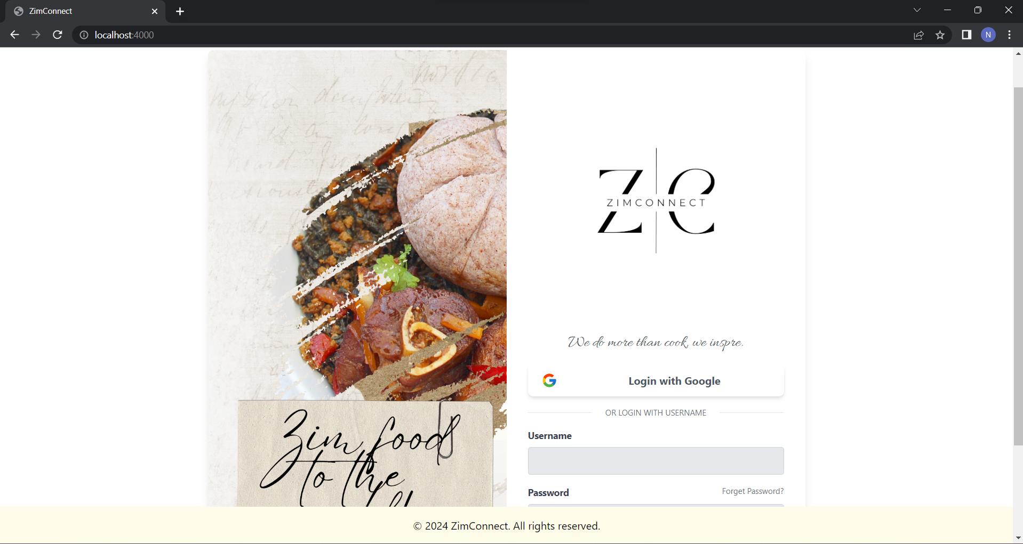

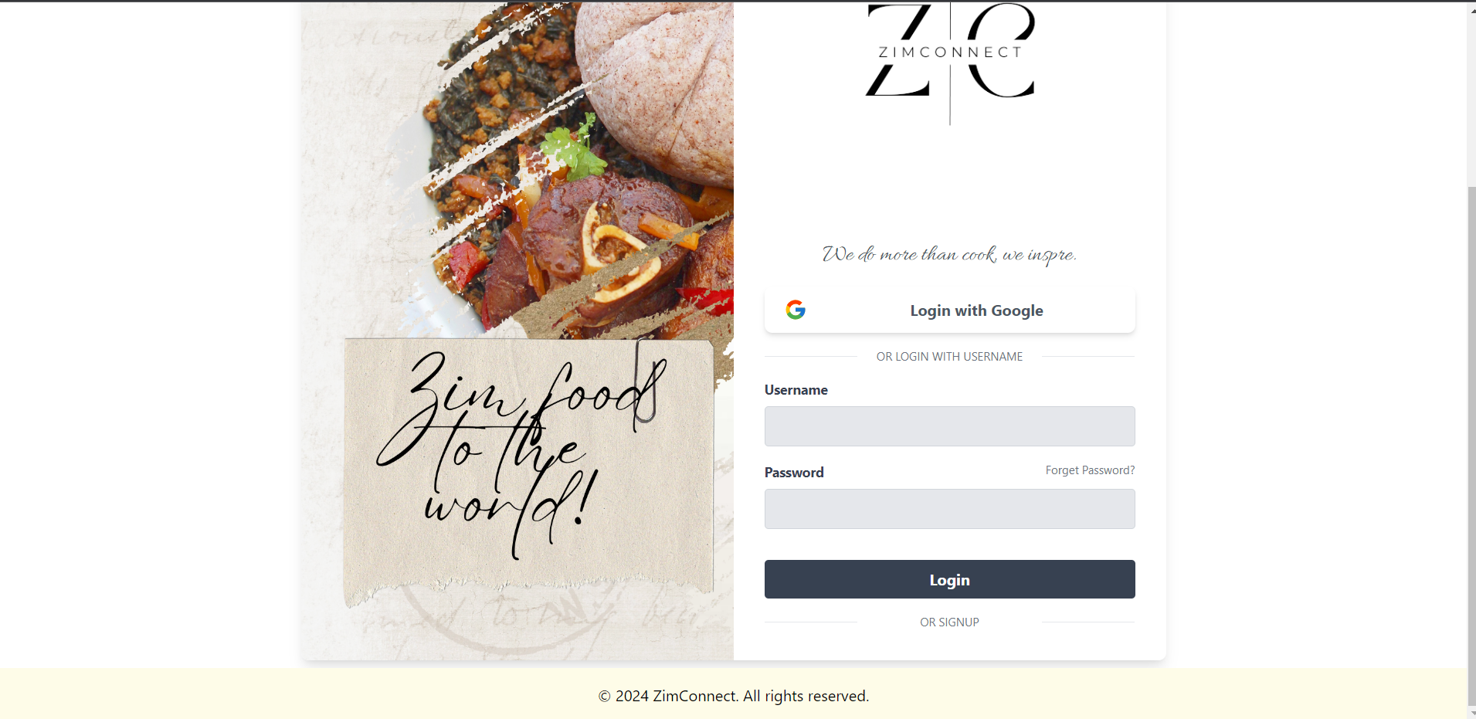

# Signup page

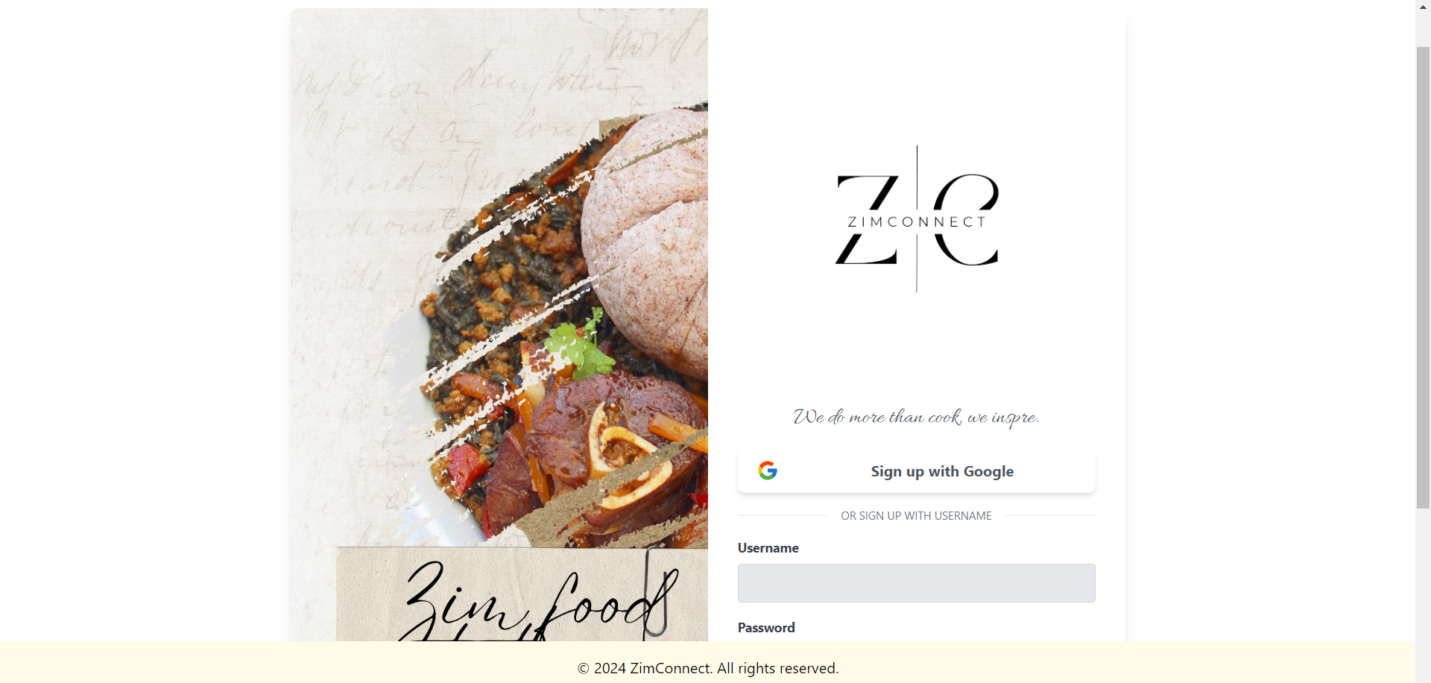

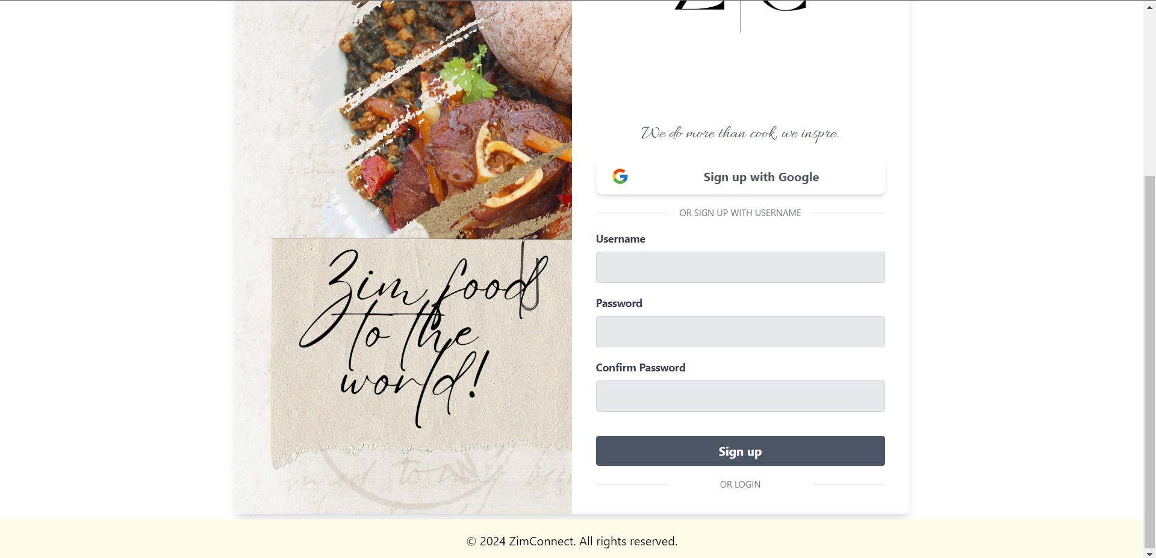

# Header

In the screenshot below the “FEED” option is being hovered over.



In the screenshot below, sample text has been inputted in the search bar.



# Feed page

The layout is shown for both, posts with pictures and posts without.

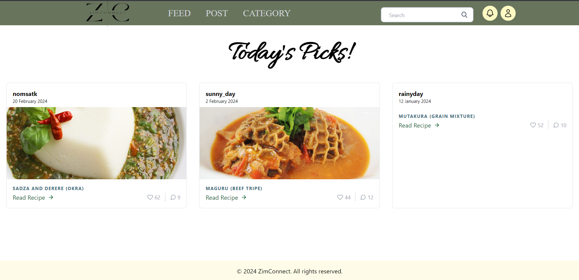

# Post page

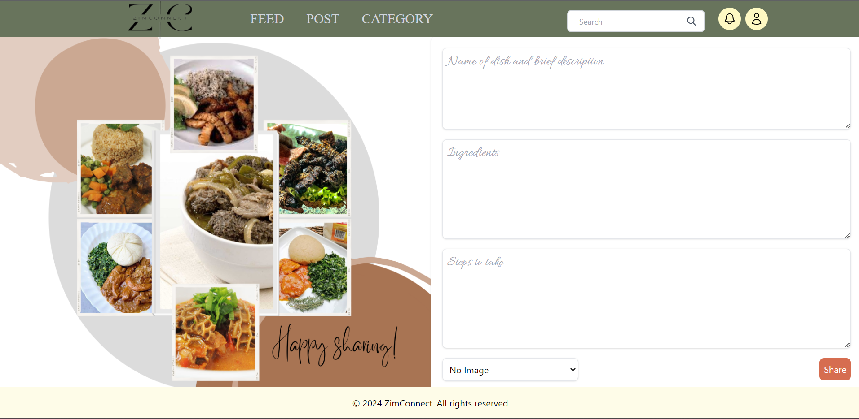

# Category page

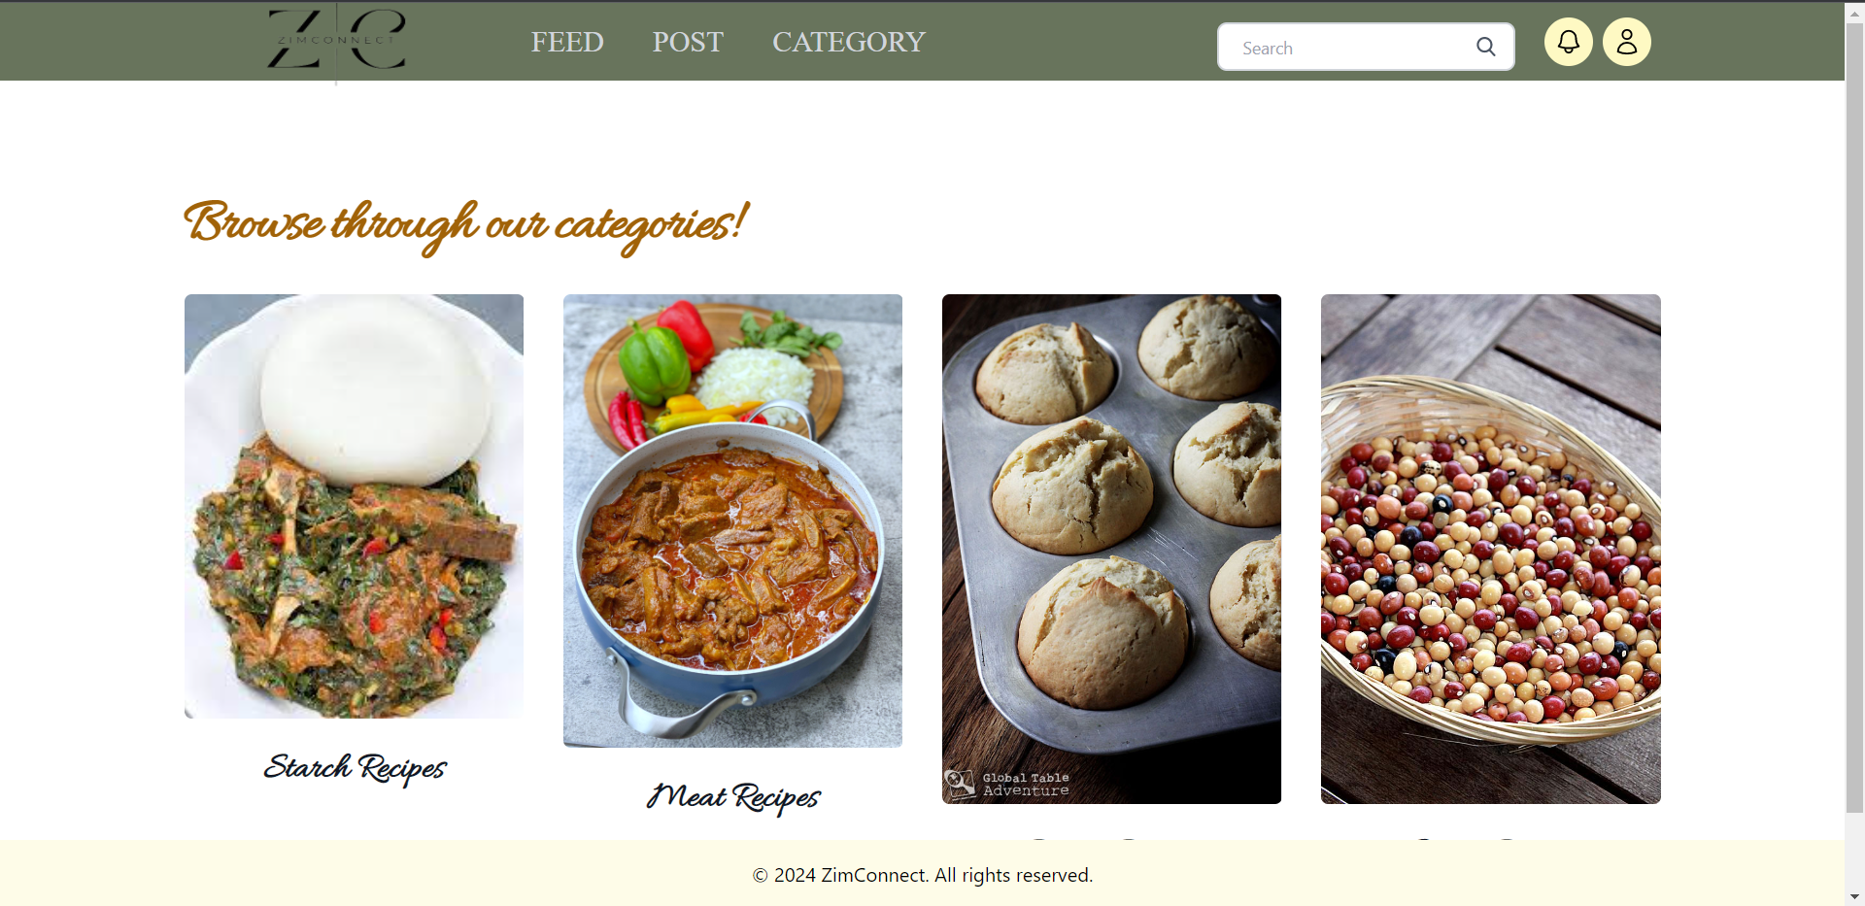

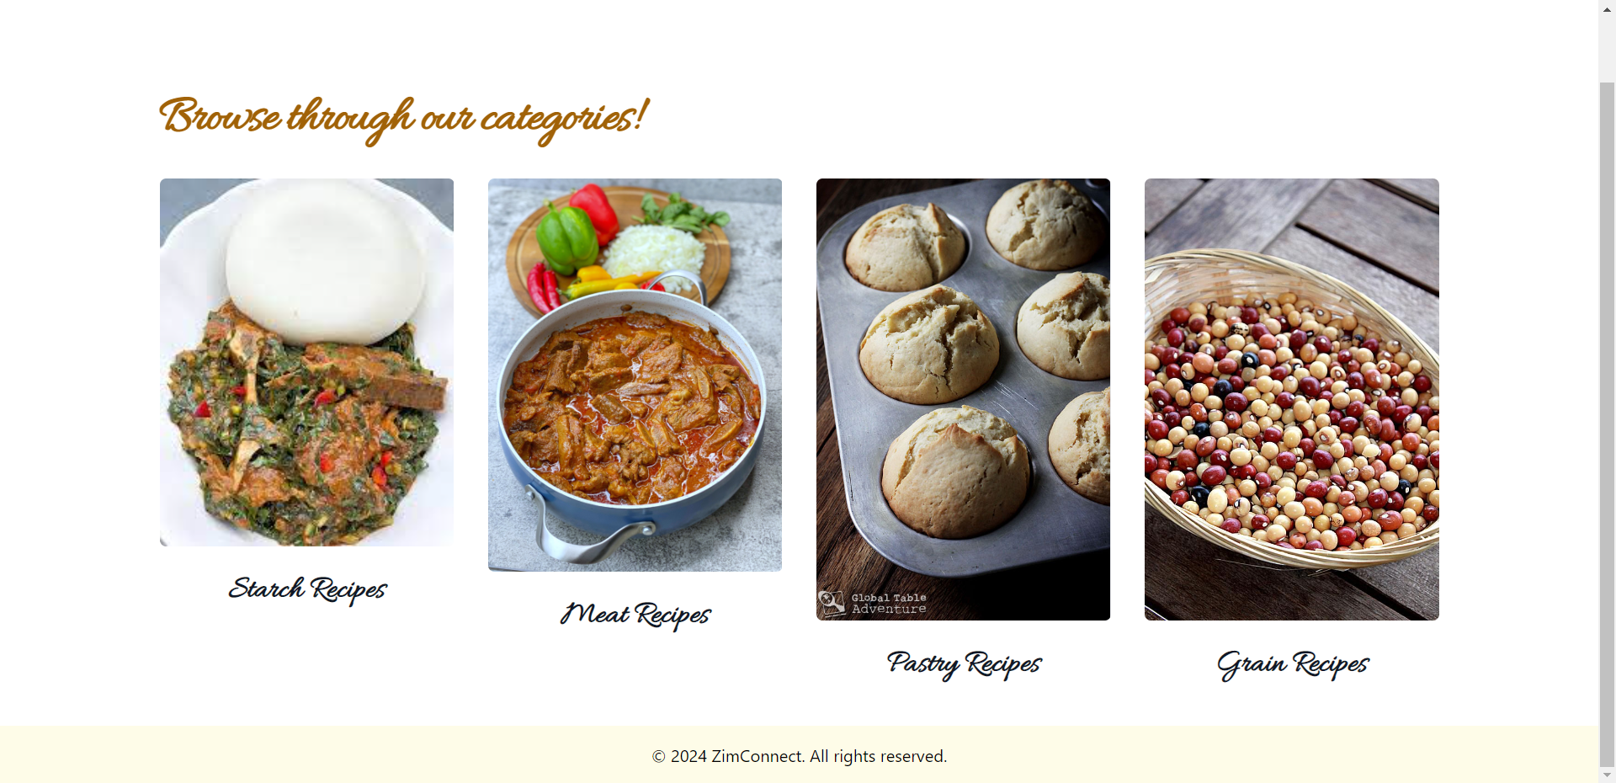

# Notification page

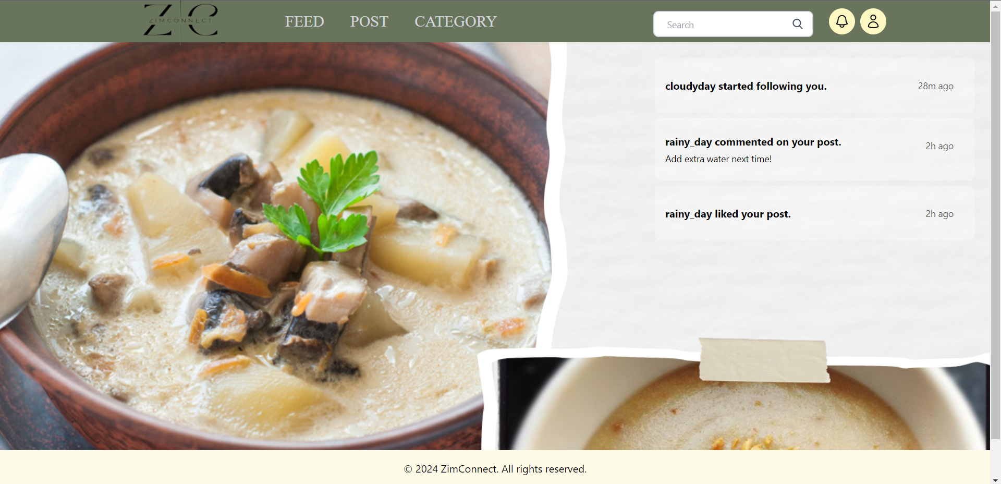

# Profile page

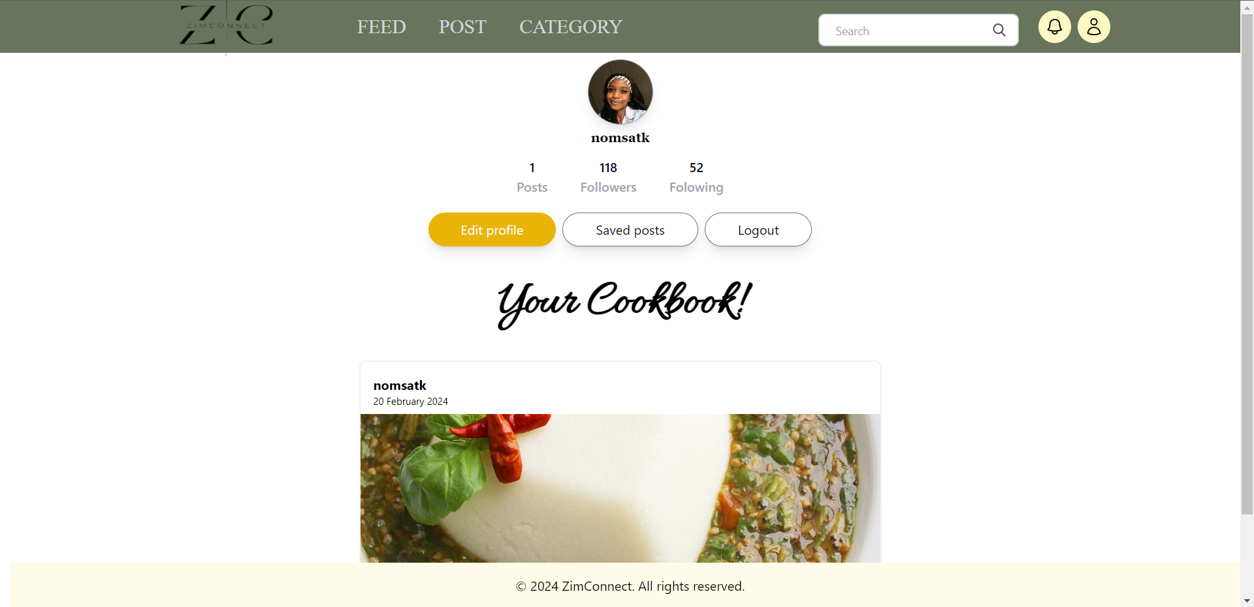

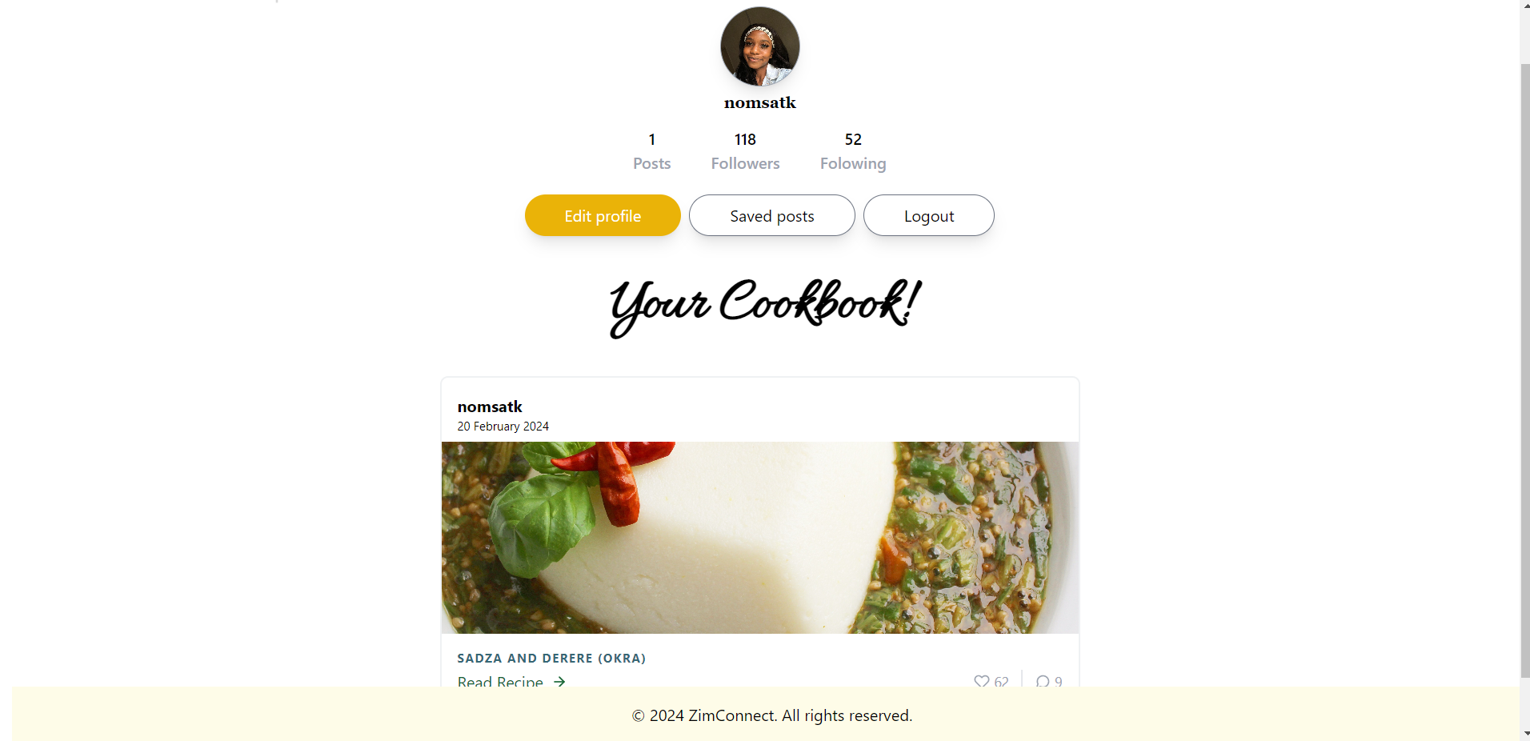

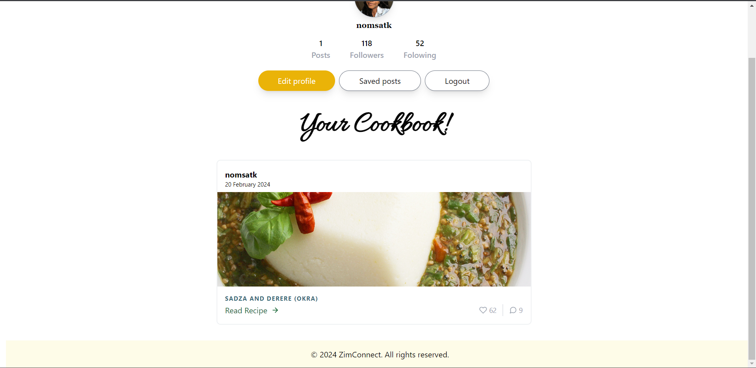

# Web service



## Example for POST

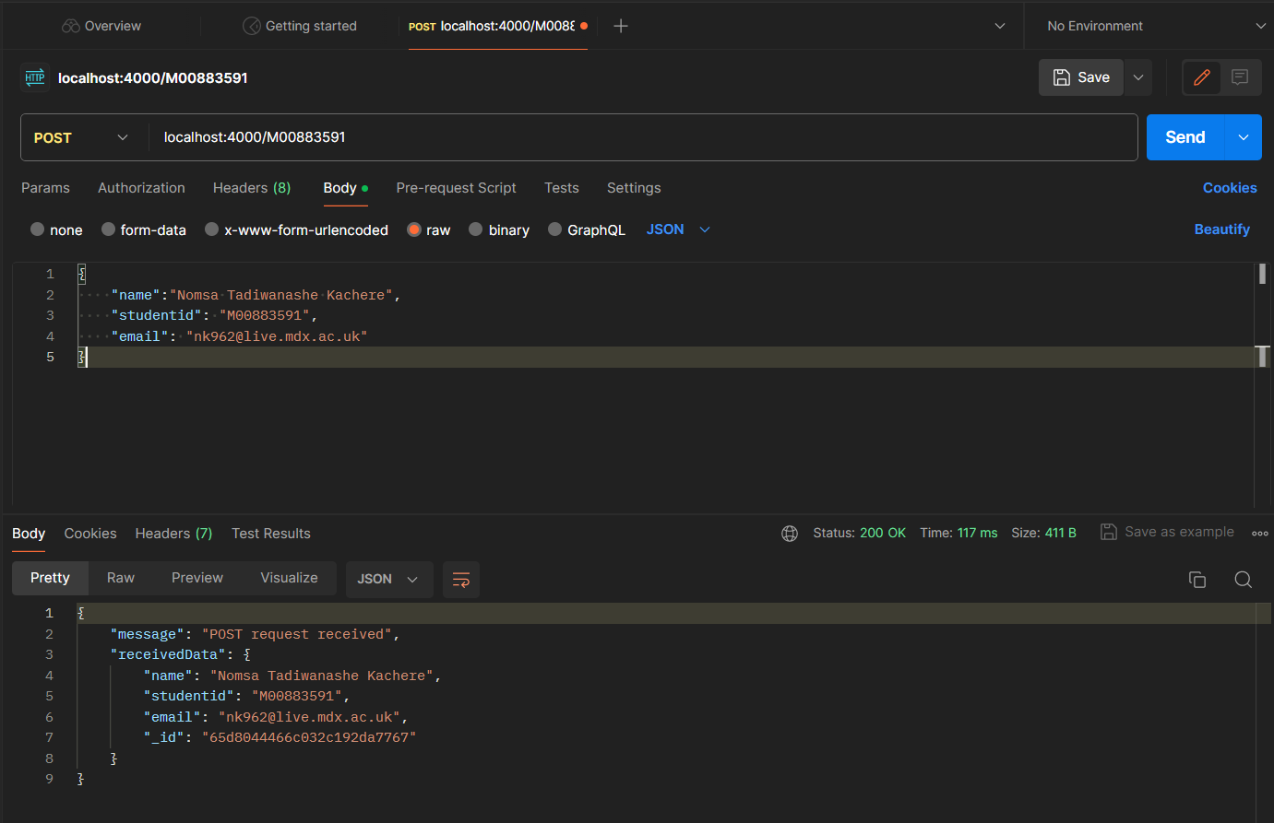

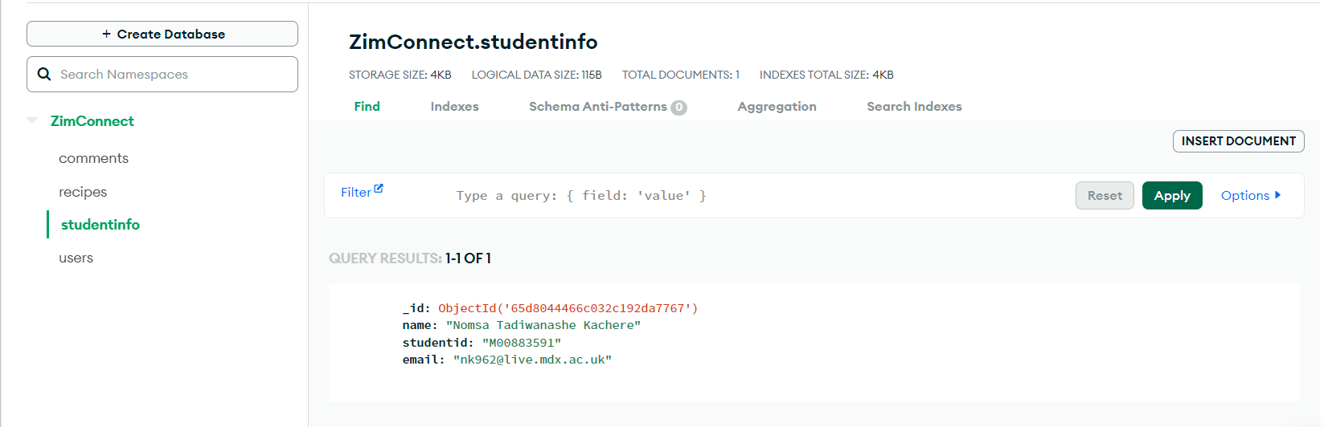

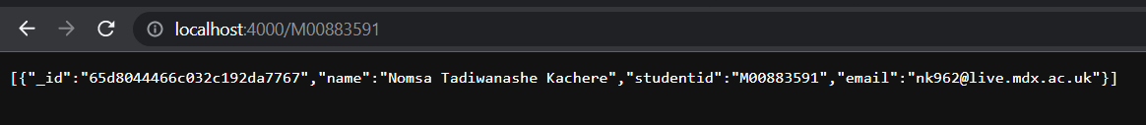

## Second example for POST

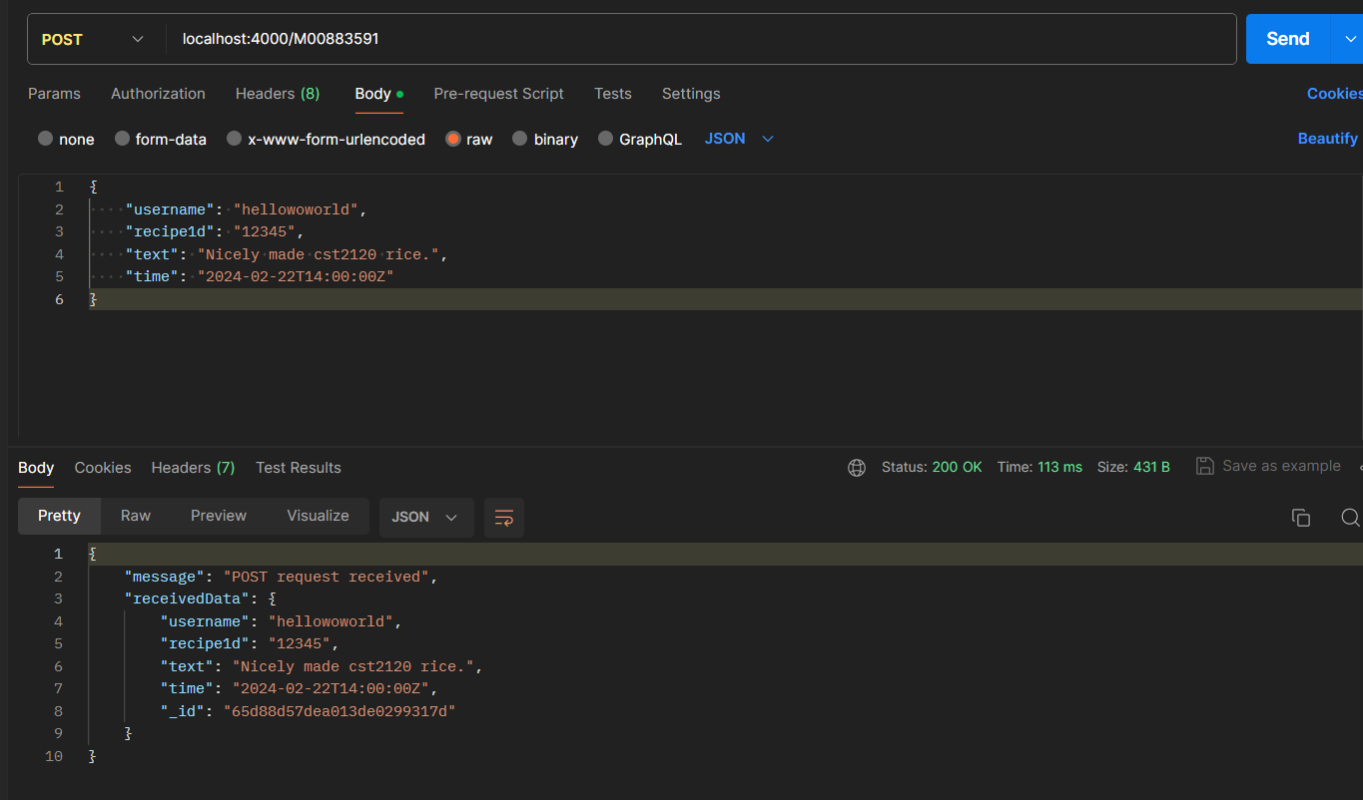

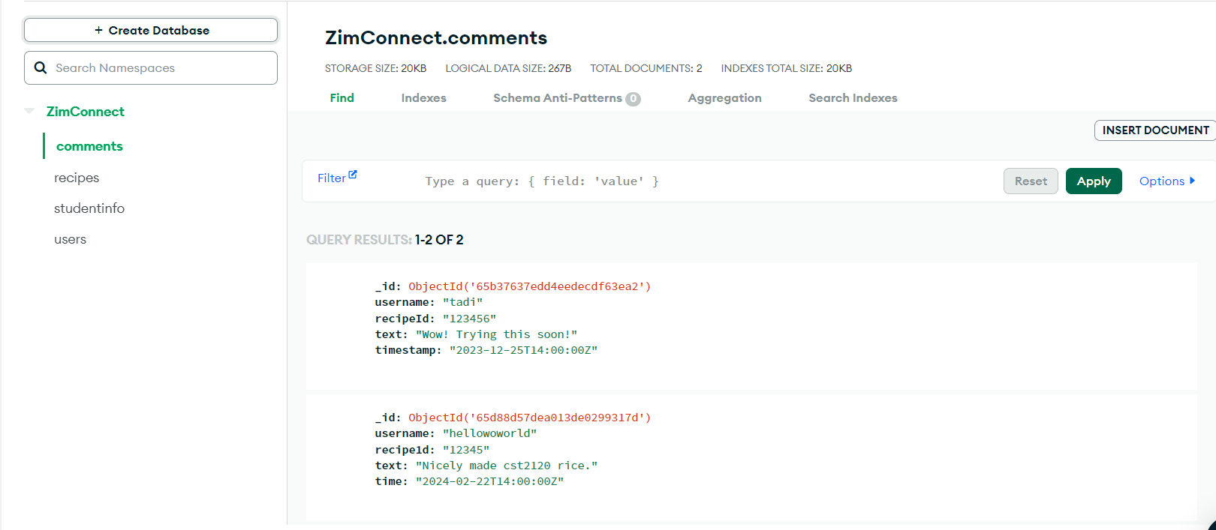



## Example for GET

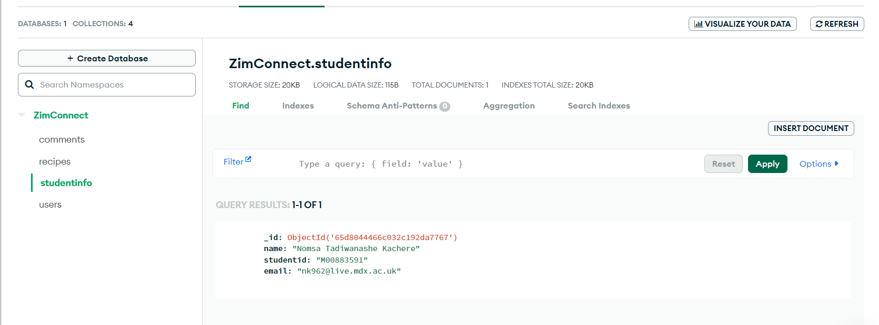

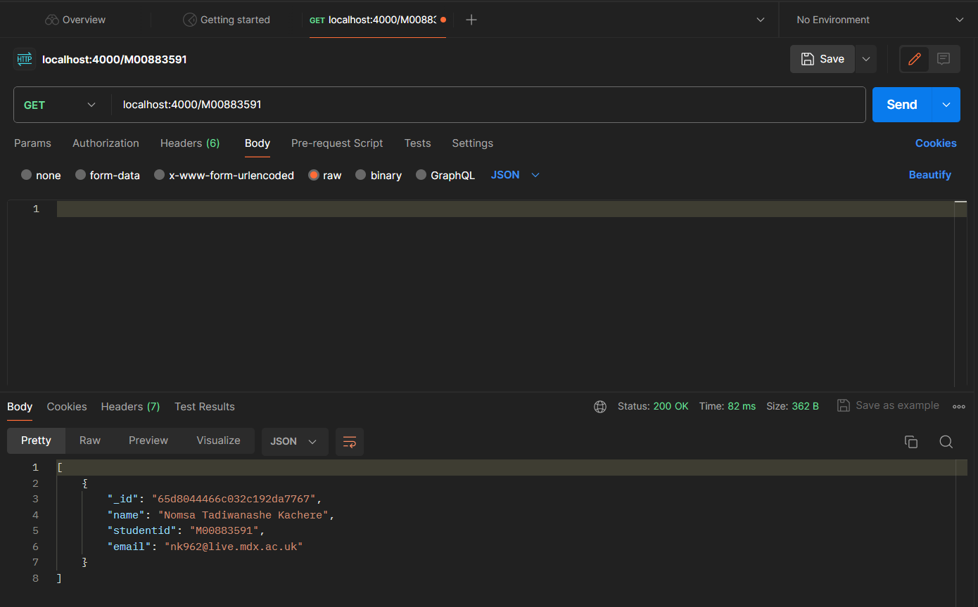

## Second example for GET

